

Recipient of the

“Young Entrepreneur of the Year”

in the Banjo Business Awards Orange 2013.

B & C Carslake Plumbing Services

271 Spring Hill Road

Spring Hill

NSW 2800

E: [bccarslakeplumbing@hotmail.com](mailto:bccarslakeplumbing@hotmail.com)

P: 0429775200

M: 0429771645

F: 02 63655017

The Reliable Tradie

Save water. Shower with a plumber

B & C Carslake Plumbing Service

Is available 24 hours a day, 7 days a week. Offering high quality work combined with a great level of communication with our customers. Our aim is to provide our customers with a hassle free service given that a high standard of work is completed in a timely manner. Our professional plumbers arrive promptly, prepared and ready to complete the work in a safe environment with due care and attention.

We offer professional advice according to Australian Standards and our own experiences. All of our plumbers are qualified, allowing our customers to have the best possible solutions presented to them. We offer alternatives where possible giving the customers the final choice.

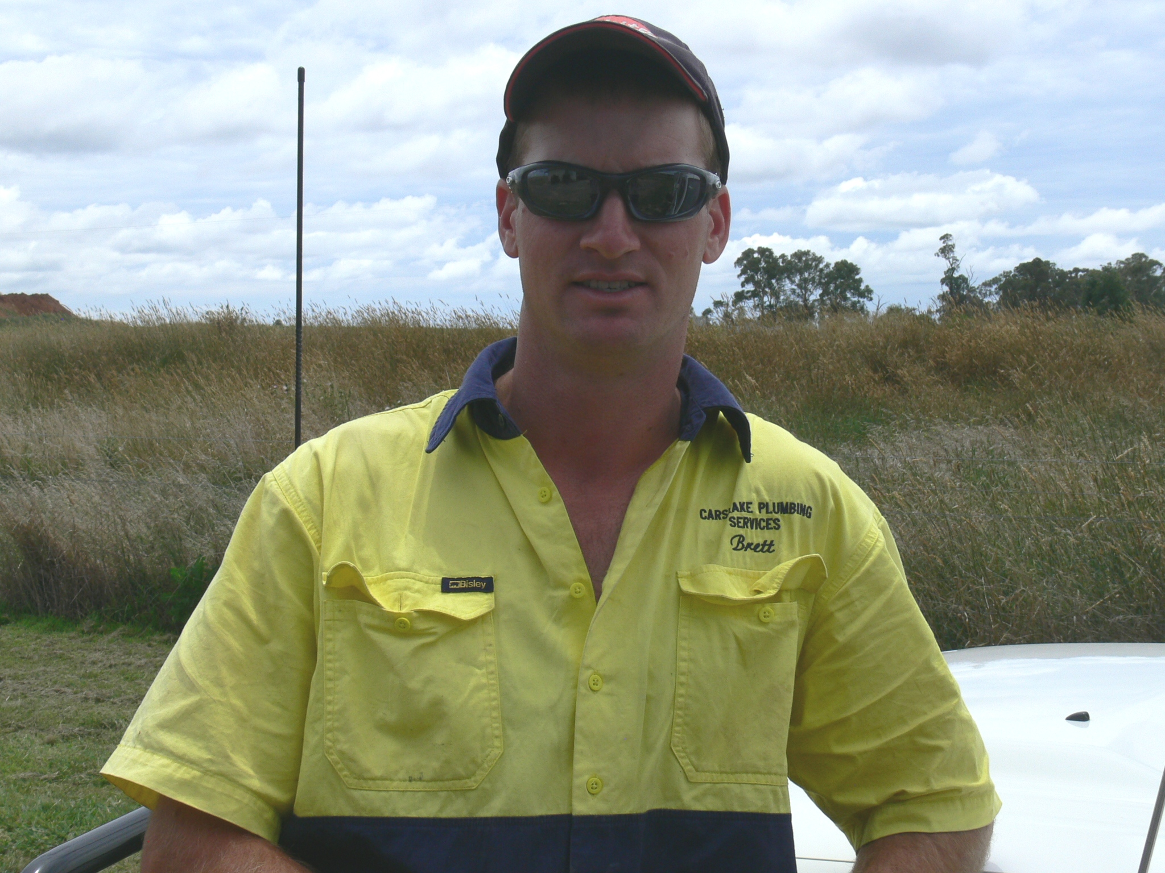

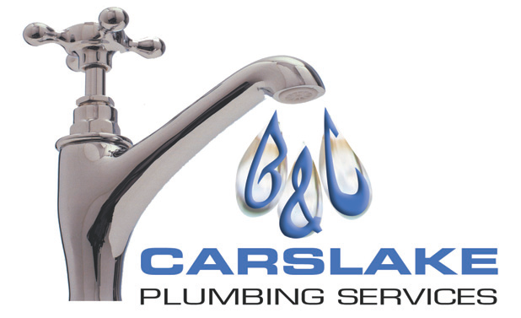

What we do!

B & C Carslake Plumbing Services

The Reliable Tradie

Plumber, Drainer, Gasfitter

Call us today on:

0429775200 or 0429771645

We provide the following:

Gas Repairs & Installations

Gutter Repairs & Installations

Rain Water Tank Set-up

Roof Repairs & Installations

Stormwater Pits & Drains

Backflow Prevention Systems

Hot Water System Repairs & Installations

New Drainage Systems

Unblocking Drains using an Electric Eel

New Home Plumbing Works

Solar Hot Water Repairs & Installations

Toilet Repairs & Installations

Bathroom Renovations

General Home Plumbing Maintenance

Commercial Plumbing Services

The Reliable Tradie

Plumber, Drainer, Gasfitter

Testimonials

“We have been using B & C Carslake Plumbing Services for the past 2.5 years, we have found Brett & Cassie to be very reliable. Their service is prompt, efficient and of a high standard, nothing is ever too much trouble. We would be happy to recommend them to anyone.”

Jane Cook

Property Manager

John Cook Real Estate

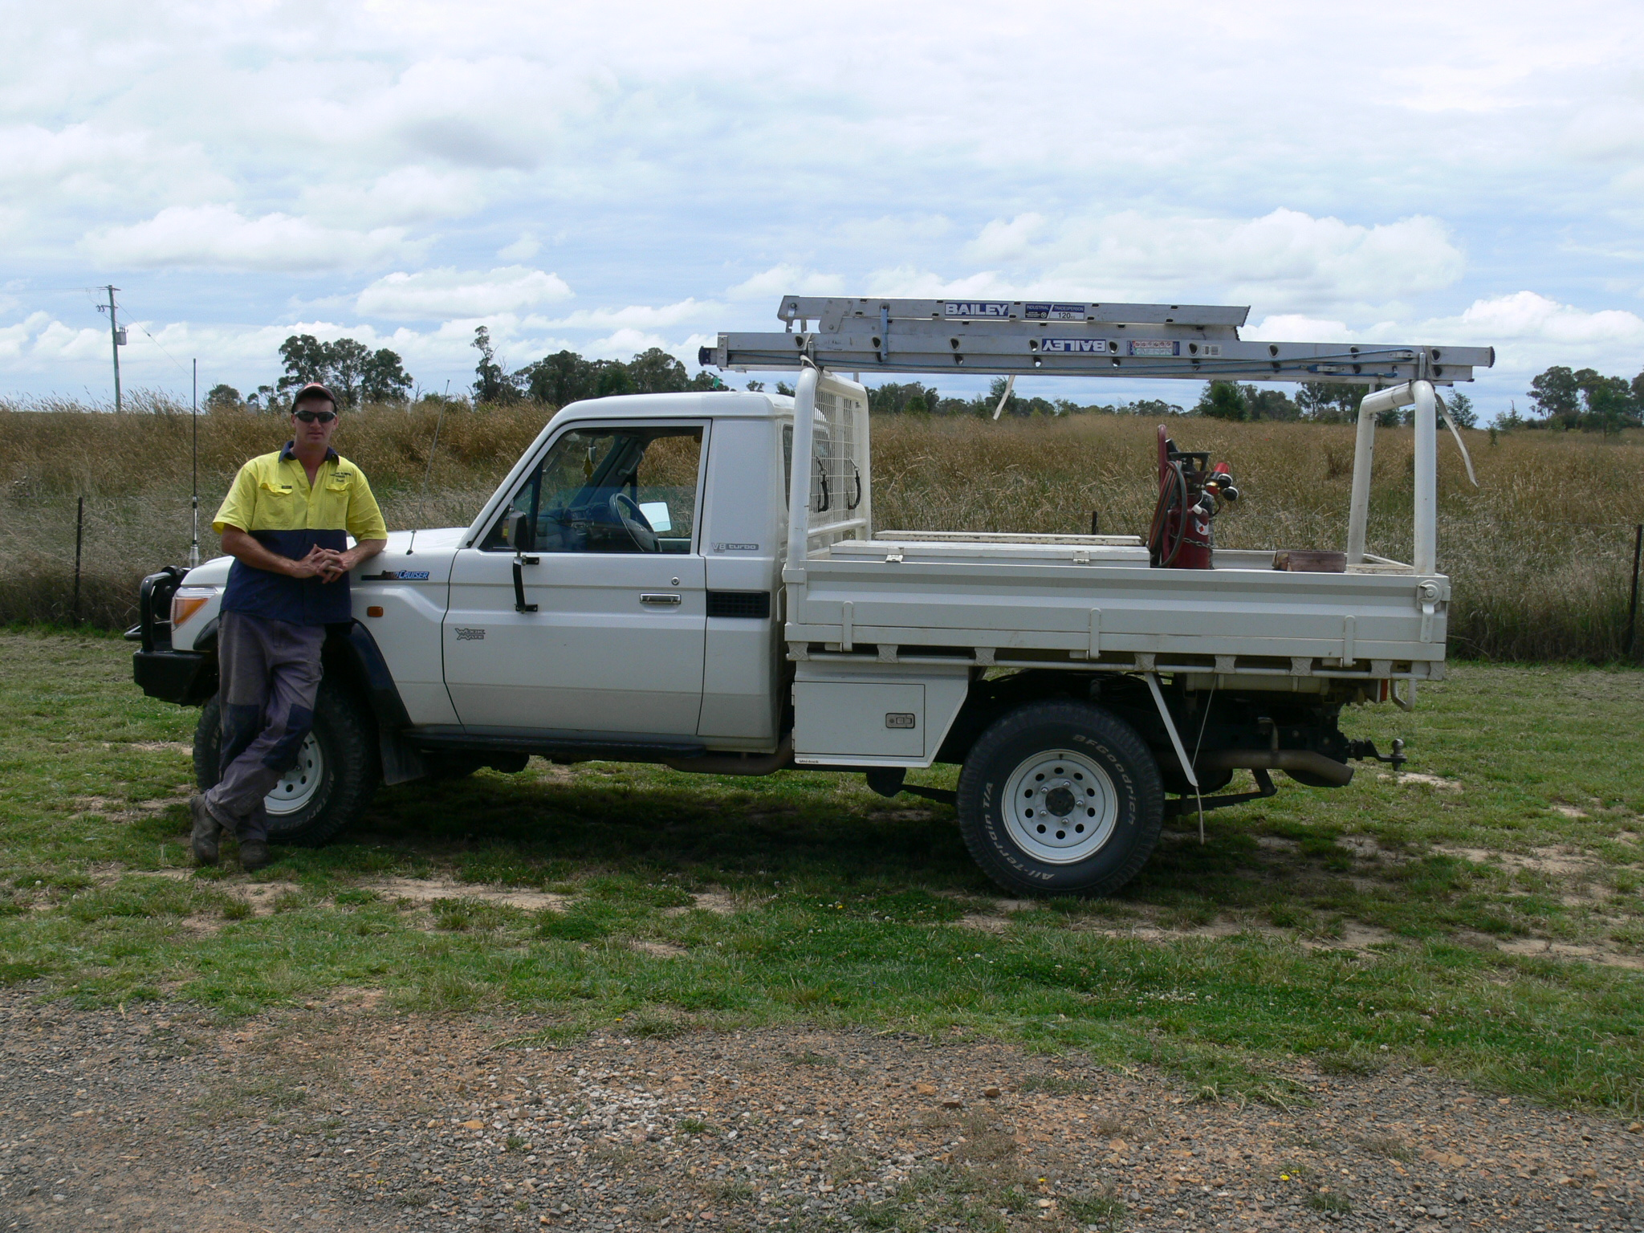

Our Services

“Thank you Carslake Plumbing for your efficiency and professionalism. I was so happy with the job that you did and the service you provided. Brett arrived on time, kept me up to date with what needed to be done and was able to work around my busy work schedule. Thank you.”

Rachel Crane

“B & C Carslake Plumbing Services are fantastic and would recommend them to anyone who needs plumbing. I will now only use your service as I still have a lot of work to get done. Your work ethics are fantastic and communication is of a high standard as I was always informed if a road block came and we needed to work around it. Thanks again.”

Vince Tine

Customer Satisfaction is something we pride ourselves on. This satisfaction comes from constant communication regarding arrival time, cost and practicality of the task at hand. We understand the need for jobs to be done quickly, hence our speedy arrival times.

B & C Carslake Plumbing Services

0429775200 or 0429771645

Testimonials